A000-ME-Egypt-Sinai- Proto-Sinaitic-Limestone-1850-1550 BCE

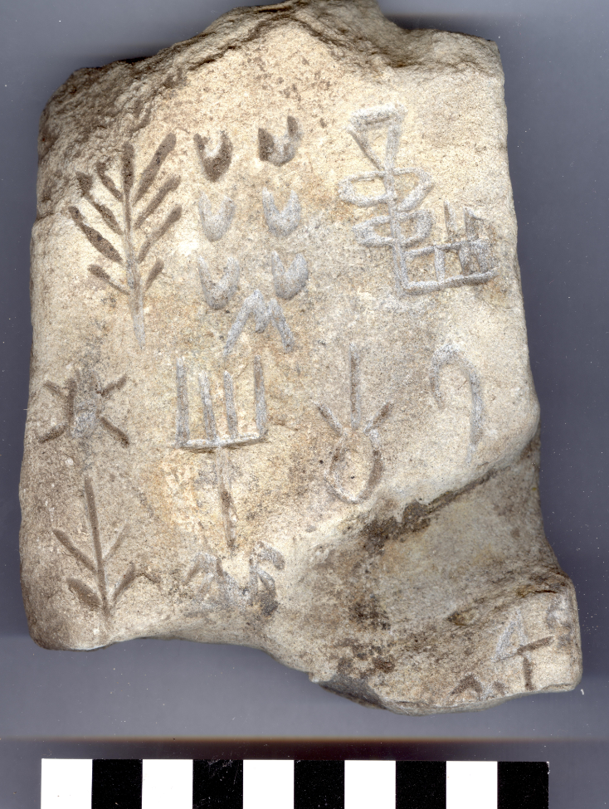

ME-Egypt-Sinai- Proto-Sinaitic-Limestone-1850-1550 BCE

**Case No.: 2**

**Accession No.**

**Formal Label:** ME-Egypt-Sinai- Proto-Sinaitic-Limestone-1850-1550 BCE

**Display Description:**

Proto-Sinaitic, also referred to as Sinaitic (1850 BCE) or Proto-Canaanite (1550 BCE), a Middle Bronze Age (Egyptian Middle Kingdom) script attested in a small corpus of inscriptions found at Serabit el-Khadim in the Sinai Peninsula, Egypt. "Proto-Sinaitic inscriptions" were discovered in the winter of 1904–1905 in Sinai by Hilda and Flinders Petrie. To this may be added a number of short "Proto-Canaanite" inscriptions found in Canaan and dated to between the 17th and 15th centuries BC, and more recently, the discovery in 1999 of the so-called "Wadi el-Hol inscriptions", found in Middle Egypt by John and Deborah Darnell. The Wadi el-Hol inscriptions strongly suggest a date of development of Proto-Sinaitic writing from the mid-19th to 18th centuries BCE.

**LC Classification:**

**Date or Time Horizon:**

**Geographical Area: Sinai**

**Map:**

**GPS coordinates:**

**Cultural Affiliation:**

**Media:**

**Dimensions:**

**Weight:**

**Condition:**

**Provenance:**

**Discussion:**

**References:**

Albright, Wm. F. (1966) The Proto-Sinaitic Inscriptions and their Decipherment

I. Biggs, M. Dijkstra, Corpus of Proto-sinaitic Inscriptions, Alter Orient und Altes Testament, Neukirchener Verlag, 1990.

Butin, Romanus (1928). "The Serabit Inscriptions: II. The Decipherment and Significance of the Inscriptions". Harvard Theological Review. 21 (1): 9–67. [doi](https://en.wikipedia.org/wiki/Digital_object_identifier):[10.1017/s0017816000021167](https://doi.org/10.1017/s0017816000021167).

Butin, Romanus (1932). "The Protosinaitic Inscriptions". Harvard Theological Review. 25 (2): 130–203. [doi](https://en.wikipedia.org/wiki/Digital_object_identifier):[10.1017/s0017816000001231](https://doi.org/10.1017/s0017816000001231).

Colless, Brian E (1990). "The proto-alphabetic inscriptions of Sinai". Abr-Nahrain / Ancient Near Eastern Studies. 28: 1–52. [doi](https://en.wikipedia.org/wiki/Digital_object_identifier):[10.2143/anes.28.0.525711](https://doi.org/10.2143/anes.28.0.525711).

Colless, Brian E (1991). "The proto-alphabetic inscriptions of Canaan". Abr-Nahrain / Ancient Near Eastern Studies. 29: 18–66. [doi](https://en.wikipedia.org/wiki/Digital_object_identifier):[10.2143/anes.29.0.525718](https://doi.org/10.2143/anes.29.0.525718).

Colless, Brian E., "The Byblos Syllabary and the Proto-alphabet", Abr-Nahrain / Ancient Near Eastern Studies 30 (1992) 15–62.

Colless, Brian E (2010). "Proto-alphabetic Inscriptions from the Wadi Arabah". Antiguo Oriente. 8: 75–96.

Colless, Brian E., "The Origin of the Alphabet: An Examination of the Goldwasser Hypothesis", Antiguo Oriente12 (2014) 71-104.

Stefan Jakob Wimmer / Samaher Wimmer-Dweikat: The Alphabet from Wadi el-Hôl – A First Try, in: [Göttinger Miszellen](https://en.wikipedia.org/wiki/G%C3%B6ttinger_Miszellen" \o "Göttinger Miszellen). Beiträge zur ägyptologischen Diskussion, Heft 180, Göttingen 2001, p. 107–111

Darnell, J. C.; Dobbs-Allsopp, F. W.; et al. (2005). "Two Early Alphabetic Inscriptions from the Wadi el-Hol: New Evidence for the Origin of the Alphabet from the Western Desert of Egypt". Annual of the American Schools of Oriental Research. 59: 63, 65, 67–71, 73–113, 115–124. [JSTOR](https://en.wikipedia.org/wiki/JSTOR) [3768583](https://www.jstor.org/stable/3768583).

Hamilton, Gordon J, The origins of the West Semitic alphabet in Egyptian scripts (2006)

Fellman, Bruce (2000) "The Birthplace of the ABCs." Yale Alumni Magazine, December 2000.[[1]](https://web.archive.org/web/20050217061048/http:/www.yalealumnimagazine.com/issues/00_12/egypt.html)

Sacks, David (2004). Letter Perfect: The Marvelous History of Our Alphabet from A to Z. Broadway Books. [ISBN](https://en.wikipedia.org/wiki/International_Standard_Book_Number) [0-7679-1173-3](https://en.wikipedia.org/wiki/Special:BookSources/0-7679-1173-3).

Goldwasser, Orly, [How the Alphabet Was Born from Hieroglyphs](http://members.bib-arch.org/publication.asp?PubID=BSBA&Volume=36&Issue=02&ArticleID=06) Biblical Archaeology Review 36:02, Mar/Apr 2010.

Lake, K.; Blake, R. (1928). "The Serabit Inscriptions: I. The Rediscovery of the Inscriptions". Harvard Theological Review. 21 (1): 1–8. [doi](https://en.wikipedia.org/wiki/Digital_object_identifier):[10.1017/s0017816000021155](https://doi.org/10.1017/s0017816000021155).

Millard, A. R. (1986) "The Infancy of the Alphabet" World Archaeology. pp. 390–398.

Ray, John D. (1986) "The Emergence of Writing in Egypt" Early Writing Systems; 17/3 pp. 307–316.

B. Benjamin Sass (West Semitic Alphabets) – In 1988 a very important doctoral dissertation was completed at Tel Aviv University, *Benjamin Sass, The Genesis of the Alphabet and its Development in the Second Millennium BC, Ägypten Und Altes Testament 13, Otto Harrassowitz, Wiesbaden, 1988.

Simons, F., "Proto-Sinaitic – Progenitor of the Alphabet" Rosetta 9 (2011), [16–40](http://www.rosetta.bham.ac.uk/issue_09/simons_alphabet.pdf).